PRESS RELEASE – 20 OCTOBER 2007
FOR IMMEDIATE RELEASE

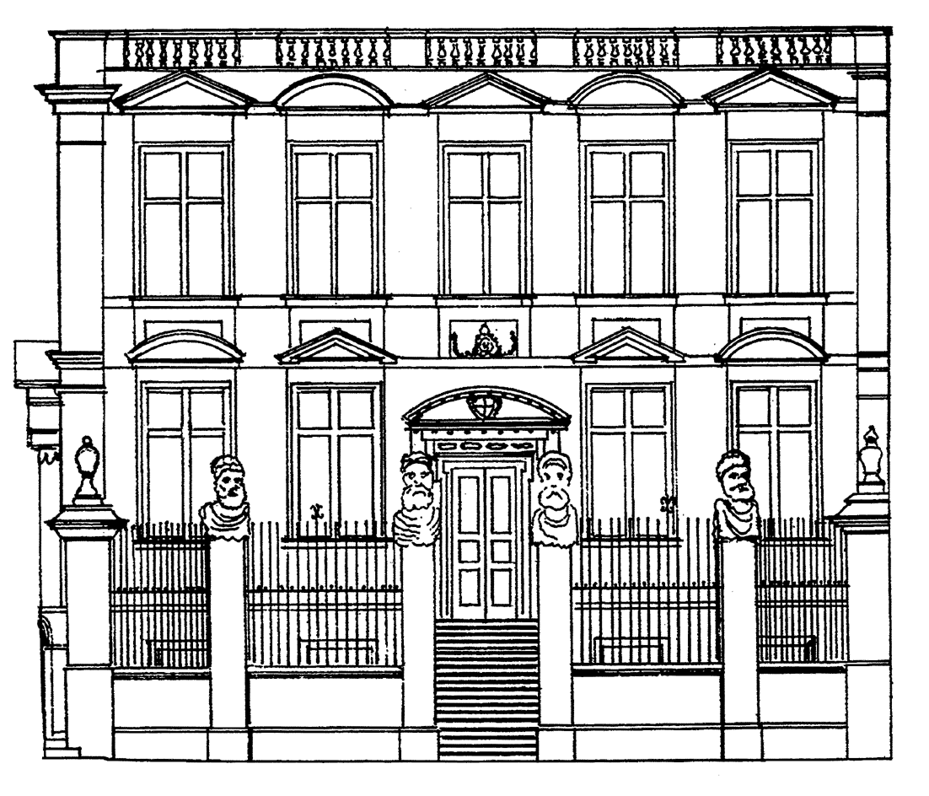
MUSEUM of the
HISTORY of
SCIENCE

Small Worlds – the art of the invisible
A special exhibition

On 31 October, Small Worlds – the Art of the Invisible will open at the Museum of the History of Science in Oxford. This new exhibition of the miniature world of microscopic specimens displays the contents of a cabinet of over 10,000 slides. Seeing the slides won’t mean peering down a microscope, however: the exhibition is a representation of the collection in poetry and art.

Artist Heather Barnett (Visiting Fellow at London School of Economics, The Other Flower Show at the V&A) specialises in exploring the intersection between contemporary art, science and technology. She has worked in collaboration with performance poet Will Holloway (formerly Mr Social Control, author of President McVeigh and Suicide Bombing is Just So Passive Aggressive). Together they have created an engaging site-specific body of work in image, animation and poetry in a strikingly designed immersive exhibition environment.

The cabinet of slides at the centre of the Small Worlds exhibition was donated to the Museum in 2005 and its contents were collected between 1860 and 1930 at a time when microscopy was a fashionable hobby. The slides contain a variety of specimens such as fungi, plant parts, animal and human tissue samples, insects and strangest of all a miniaturised photograph of a hunting expedition. Visitors to the exhibition will discover these specimens in all sorts of weird and wonderful ways including plankton-patterned curtains, animations and audio poems.

Heather Barnett says “We want to take the audience on a journey, playing with ideas of scale, vision, different ways of making the invisible visible, and with the relationship between the small worlds of microscopy and the macroscopic world. We really want to give people the experience of being under the microscope.” A full schedule of events and workshops is planned to coincide with the Small Worlds Exhibition.

[Ends 1 of 1]
Notes to Editors:

Small Worlds Exhibition: 31 October 2007 – April 2008

Exhibition preview: 30 October 2007, 6pm – 8pm.

Admission free

Museum of the History of Science
Broad Street, Oxford, OX1 3AZ

Museum opening times:
Tuesday to Friday 12.00 – 17.00
Saturday 10.00 – 17.00
Sunday 14.00 – 17.00

Online exhibition and artists’ blogs available at: www.mhs.ox.ac.uk/smallworlds

Events programme:

Under the Microscope: 10 November, 2 – 4pm, 19 January, 2 – 4pm, ages 9+.
Seeing the Invisible (table talk): 4 November, 2.30pm
Poetry Slam: 7 December, 7 – 11pm
Molecules to Organisms (Public Lecture by Prof. Denis Noble): 22 January, 7pm
Small and Shocking: Miscroscopy in Restoration London (afternoon of events including readings, drama and talks): 9 February, 2pm
The Solar Microscope (table talk): 17 February, 2.30pm
Big Questions about Small Worlds (Public Lecture by Prof. Rom Harre): 5 March, 7pm
Secrets of Nature: how the microscope brought an invisible world to cinema (Public Lecture by Dr Tim Boon): 11 March, 7pm
Gulliver’s Worlds (a day of storytelling, talks and activities): 5 April, 10am – 5pm

For artists biographies and further information please see:

www.heatherbarnett.co.uk
www.willholloway.com

Broad Sheet (an occasional publication communicating the work of the Museum of the History of Science): A Broad Sheet containing poems by Will Holloway will be available from the Museum shop at a cost of £1, or can be downloaded free of charge from the website.

For more information, interviews or if you would like to attend the exhibition preview, please contact Laura Ashby on: 01865 287241 or email: laura.ashby@mhs.ox.ac.uk.

