Text supplied by Floris Winckel on 6 July 2020, from MSc research conducted at Oxford in the academic year 2019-20.

I would like to focus on one particular instance of interaction with the Westmorland Lodestone (henceforth WL), which supposedly occurred during the 1832 meeting of the British Association for the Advancement of Science (BAAS) in Oxford. At this meeting, the famous electrician Michael Faraday (1791-1867) is said to have been ‘requested by some of the authorities to repeat the celebrated experiment of eliciting a spark from a magnet, employing for this purpose the large magnet in the Ashmolean Museum [presumably the WL]’. This brief account is given to us in a footnote by John Tyndall – who had heard it from a friend – in his book Faraday as a discoverer, published thirty-six years after the event. His is the only account of the experiment; at no point does the BAAS report of this meeting mention Faraday’s demonstration of the electric spark. On 20 June 1832, Professor James Cumming (1777-1861) delivered a report on the state of thermo-electrical research, in which he mentioned that he is particularly happy, ‘since we are not fortunate as to receive instruction from the discoverer himself,- that Dr. Ritchie has undertaken to exhibit and explain to us the recent researchers of Mr. Faraday’. Indeed, later that evening, this Dr. Ritchie gave a lecture on magnetic electricity in the music room (most likely the Holywell Music Room). These are the closest references to Faraday’s work we can find in the report, and they tell us two things. First, Faraday was not present to lecture or give demonstrations on his work (at least on the day his work was being discussed), directly contradicting the account which purported that he conducted the electric spark experiment. Second, if we give Tyndall the benefit of the doubt and assume the WL was used to elicit this spark, probably during Dr. Ritchie’s lecture (albeit without Faraday present), it would have been taken out of the museum and transported to the music room especially for this purpose, which seems like an awful lot of effort for something which received no mention at all in the final report, not to mention the fact that Tyndall implies the experiment was very much an impromptu suggestion from the ‘authorities’ present.

I believe the credibility of Tyndall’s account is further undermined when we consider the viability of the experiment itself. Eliciting a sizeable spark from a natural magnet like the WL was only recently proved to be possible by the time Faraday supposedly managed it in Oxford, but only under particular conditions and using particular tools. The Italians Leopoldo Nobili and Vincenzo Antinori were the first to elicit such a spark on 31 January 1832, inspired by Faraday’s success in drawing a spark from an electro-magnet in two months earlier. A paper read to the Royal Society by James Forbes (1809-1868), a Scottish physicist, on 16 April 1832 – two months before the BAAS meeting in Oxford – explains how there were two ways one could use a magnet to elicit a spark: either by moving a magnetic bar across the axis of a helix of copper wire, or by causing a piece of soft iron to connect to the poles of a horse-shoe magnet, thus temporarily acquiring polarity. If the WL was used to elicit a spark, the second method would have to have been used, as there was no way to pass anything through the stone. We know that it was possible to use a rock similar to the WL to elicit a spark, as Forbes mentions how he used another lodestone owned by the Royal Society of Edinburgh that could support 170 lbs (similar to the WL) to do just that on 13 April. To set up the experiment, the poles of the natural magnet A needed to be in close proximity to an iron rod ab, around which a copper wire was coiled (Figure 1). Both ends of the wire were first passed through cups of mercury before terminating in a glass tube filled with mercury. To elicit a spark in the glass tube, one end of the wire would need to be abruptly separated from the mercury at the same time when the poles of the magnet are brought into contact with the iron rod. If the mercury was impure, the poles of the magnet not smooth enough to ensure good contact with the rod, or the timing not exactly simultaneous, no spark would be seen. Nobili, Antinori, and Forbes improved the design of the experiment by creating mechanical constructions which allowed them to precisely control the movement of the magnet and hence the timing of the connection, but these required ‘very considerable nicety in their execution’, and an ‘accurate assistant’ to operate them. The best success-rate achieved by Forbes was two out of every three attempts. Faraday’s experiments, on the hand, are reported to have been ‘perfectly successful’.
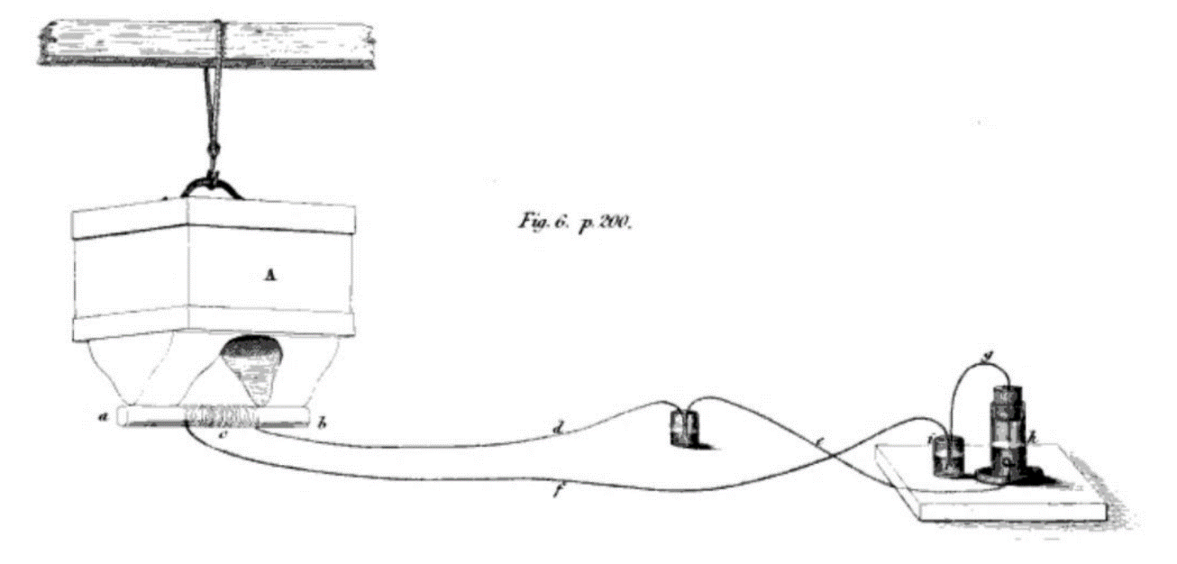
Figure 1 – The experimental setup required to elicit a spark from a natural magnet in mid-1832. Forbes, 'Account of some Experiments', p. 200.

In a postscript to his paper, added on 7 May 1832, Forbes notes that to his knowledge ‘no one except Signori Nobili and Antinori and myself have yet obtained the spark from the natural or permanent magnet’, making Faraday’s supposed spark on 20 June even less likely (but not impossible). In any case, the experiment was highly dependent on the apparatus and the gestures of the demonstrator; the only successful attempts leading up to June 1832 involved custom-made contraptions. The WL’s elaborate keeper and surrounding metal bars would most likely have prevented smooth connection with the iron rod. The contraption which suspends the WL also does not allow for precise movement as is required in the experiment. Even if the WL was able to be used for this experiment, it could not have been a spontaneous demonstration , as implied by Tyndall. Perhaps most surprising of all is that Faraday does not mention performing this remarkable experiment in a letter addressed to Joseph Louis Gay-Lussac (1778-1850), editor of the French journal Annales de chimie et de physique, dated 1 December 1832, in which he critiques Nobili and Antinori’s reports of their version of the experiment using his own accounts. Clearly, the evidence that this experiment with the WL took place is circumstantial at best, and I believe it is unlikely that this experiment was done with the WL, at least in the way it has been recorded.

John Tyndall, Faraday as a discoverer (1868), p. 32.Tyndall’s account is later quoted in M. G Brock and M. C Curthoys, The history of the University of Oxford. The Nineteenth Century Part I, 6 (Oxford, 1984), p. 18.
Neither does the report of the meeting given in the Philosophical Magazine published only a few weeks after it was held. ‘British association for the advancement of science’, The London, Edinburgh, and Dublin Philosophical Magazine and Journal of Science 1:1 (1832), pp. 77–82.
British Association for the Advancement of Science., Report of the British Association for the Advancement of Science. 1st & 2nd Meeting (1831-1832) (London, 1835), p. 301.
Ibid., p. 100.
Michael Faraday, Henri Becquerel, André-Marie Ampère, Leopoldo Nobili, and Vincenzo Antinori, ‘Divers Notices sur les Courans électriques produits soit par d’autres courans, soit par des aimans. Extrait d’une lettre de M. Faraday à M. Hachette, communiqué à l’Académie des Sciences le 17 décembre’ Annales de chimie et de physique 48 (1831), pp. 412–420; See also the report of Faraday’s experiment, which followed numerous unsuccessful attempts, Samuel Hunter Christie and John Bostock, ‘Report on Mr. Faraday’s Paper, read before the Royal Society on December 15, 1831, and entitled “Experimental Researches in Electricity”’ The London, Edinburgh, and Dublin Philosophical Magazine and Journal of Science 1:1 (1832), p. 63.
James D. Forbes, ‘IX. Account of some Experiments in which an Electric Spark was elicited from a Natural Magnet’ Transactions of the Royal Society of Edinburgh XII (1834), pp. 199–202.
Ibid., p. 202; Faraday, Becquerel, Ampère, Nobili, and Antinori, ‘Divers Notices’, pp. 419–420.
Tyndall, Faraday, p. 32.
Forbes, ‘Account’, p. 204.
Even the request to ‘repeat’ his experiment is dodgy, given that there is no evidence that he had done this experiment with a natural magnet by June.
Michael Faraday, ‘Lettre adressée à M. Gay-Lussac par M. Faraday, sur les phènomènes électro-magnétiques’ Annales de chimie et de physique 51 (1832), pp. 404–434.

